**UNLOCKING INSIGHTS INTO THE GLOBAL AIR TRANSPORTATION NETWORK**

**TEAM NO : 3**

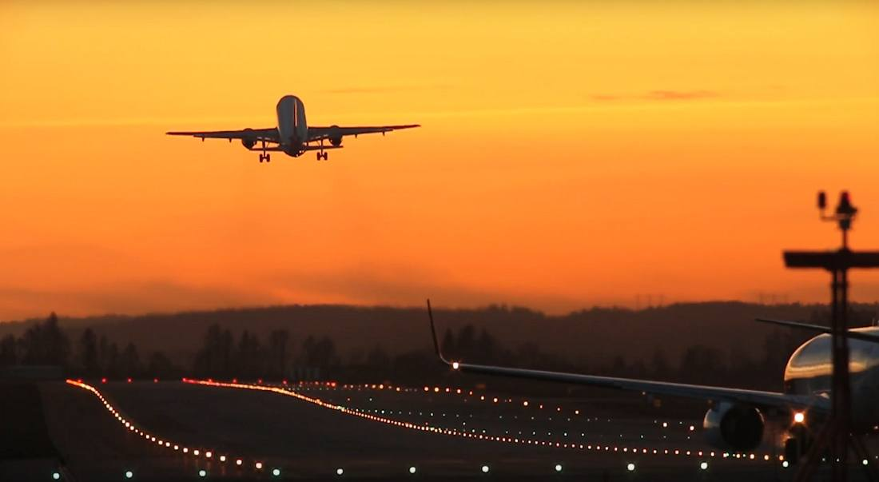

PARASURAMAN J

TEAM NO : 3

GOVERNMENT ARTS COLLEGE FOR MEN, NANDANAM

**1 INTRODUCTION**

My project explains the global air transportation present in through the world wide….

1.1 OVER VIEW

My team’s this project explains that global air transportation…

1.2 PURPOSE

This project explains global air transportation in world wide…

**2 PROBLEM DEFINITION & DESIGN THINKING**

2.2 EMPATHY MAP

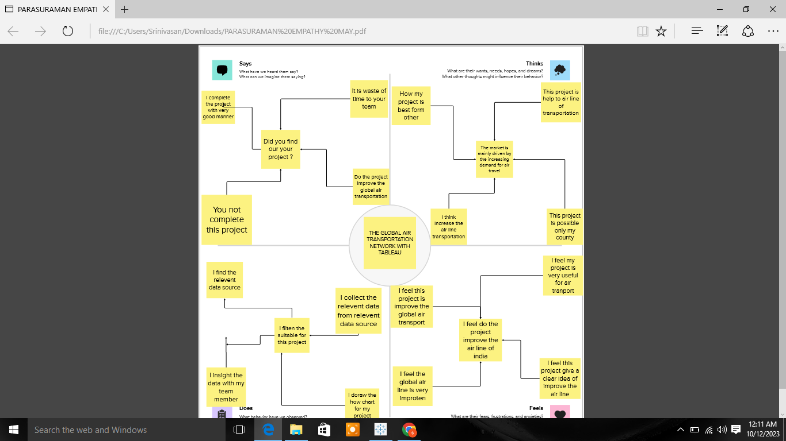

2.2 IDEATIONN & BRAINSTORMING MAP

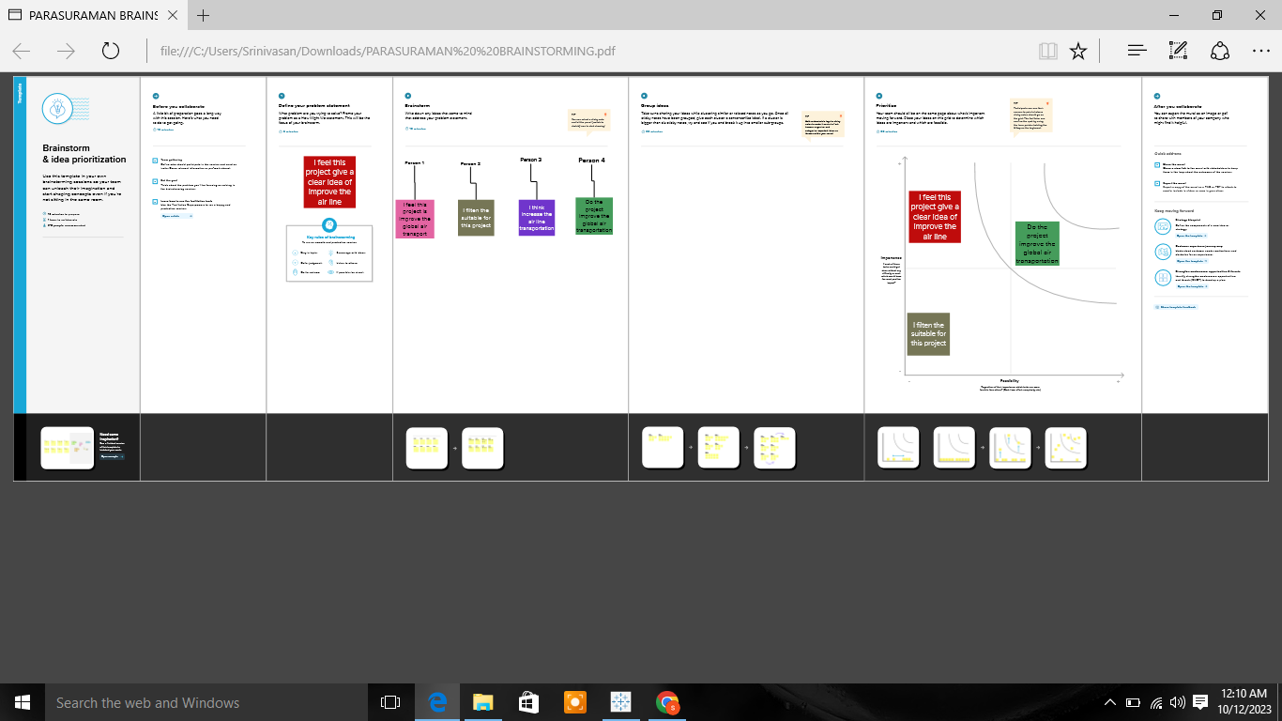

**3 RESULT**

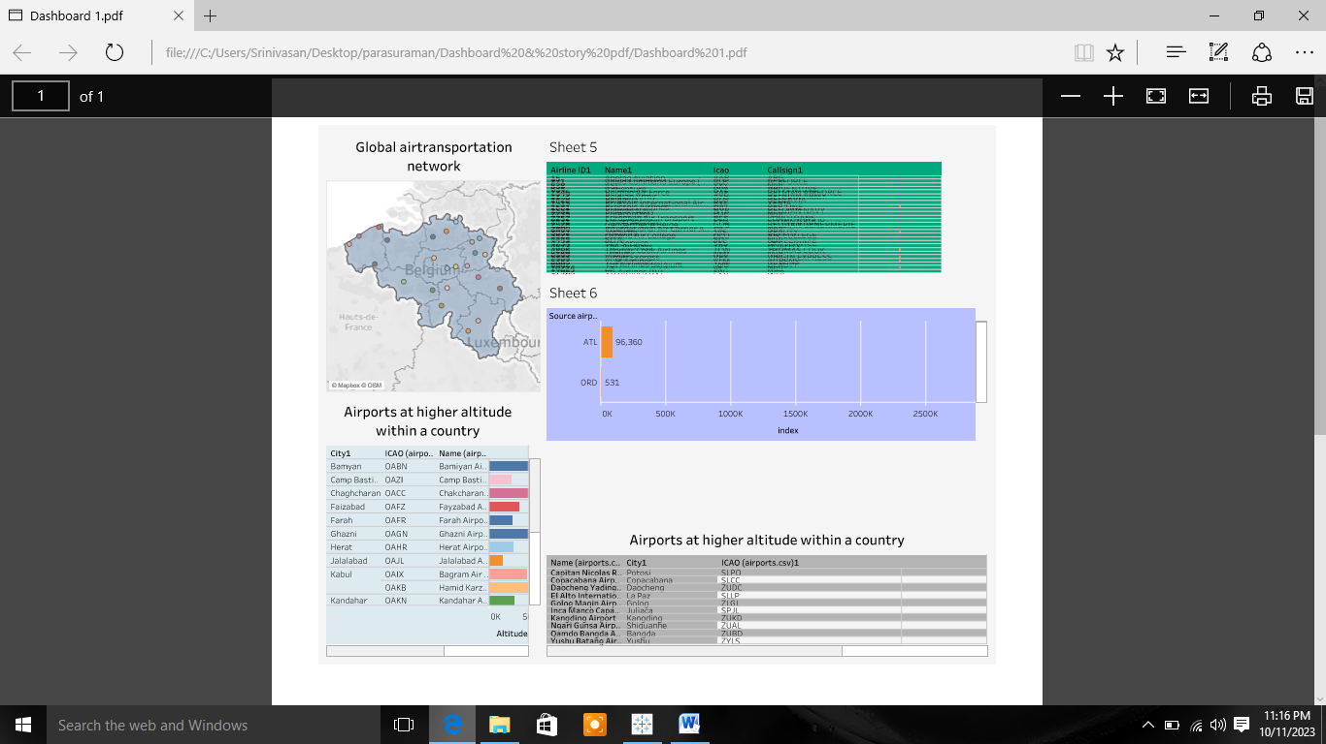

**4 (1) ADVANTAGES**

* High Speed. Air is the type of freight capable of traveling long distances in short periods of time.
* Fast Service. ...
* Send almost everywhere your freight.
* There is less need for heavy packaging.

**4 (1) DISADVANTAGES**

* Risky. Air travel is the riskiest mode of transport, since there can be considerable losses to goods, customer and crews as a result of a minor crash.
* Some Product Limitation.
* air transport can involve higher costs than other options, and is not suitable for all goods.

**5 APPLICATIONS**

* provide direct flight connections to major global hubs in North America, Europe, Asia, and the Middle East
* Air transport facilitates integration into the global economy and provides vital connectivity on a national, regional, and international scale.
* promoting tourism in India and overseas by facilitating quick and efficient travel to various destinations across the country.

**6 CONCLUSION**

This project explains the global air transportation…

**7 FUTURE SCOPE**

* Emerging technologies are reshaping with robotics, artificial intelligence, the internet of things, unmanned aircraft systems and the push for hybrid and electric airplanes – just to name a few.
* Alternative fuels can significantly change the current scenario of aviation in support of the environmental protection.
* artificial intelligence, data analytics, and automation revolutionize the industry, professionals with expertise in these areas will be in high demand.